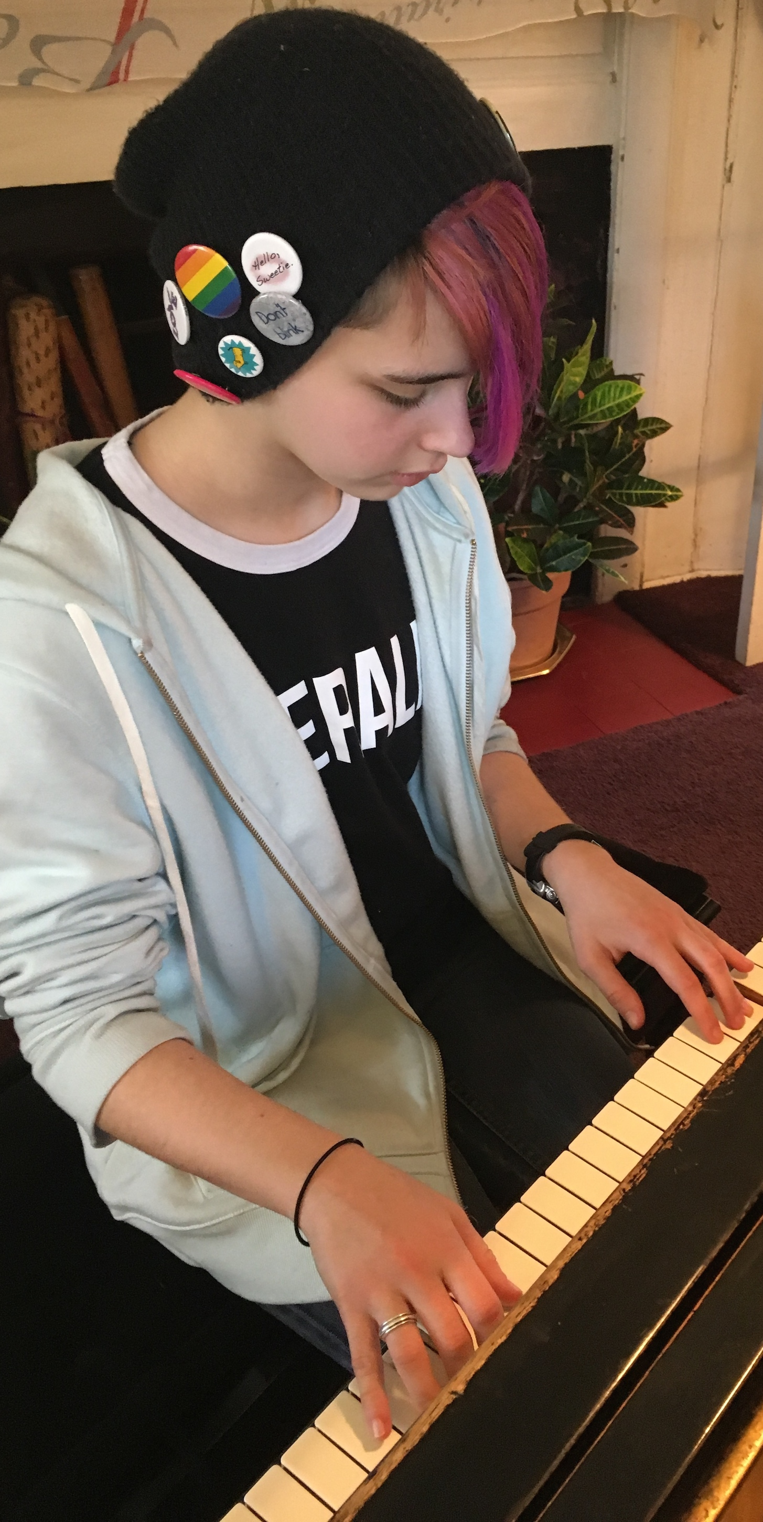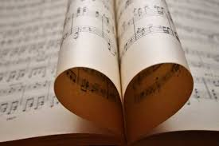

**MUSIC for GOOD!!**

Music is a powerful force for good. People who hear music, especially those who may not have a lot of opportunity to hear live music, are given a chance to hum along, move a little, think of happy times they may have had and enjoy being with others who are listening. Also, your music can benefit a good cause, as in the Thanksgiving Playathon that raises funds for homelessness. As a pianist, YOU have the power to offer your music to someone who would benefit from it. This year, everyone in the studio will participate in an outside concert – either one I arrange or one you arrange yourself! Start thinking about where and when you might like to play. More info soon!

**Your Photo Here**:

Alison S. Barr Music Associates

2017-2018

Special Project